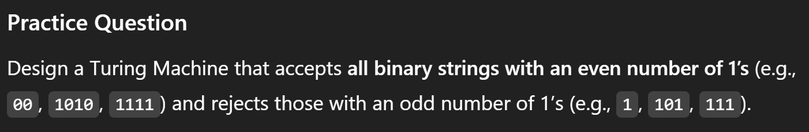

Tape alphabet: {start, 0, 1, Blank}
States: {q_init, q_even, q_odd, q_halt, q_rej}
Start_state: {q_init}
Accept: {q_halt}
Reject: {q_rej}

(q_init, start) (q_start, start, R)

Even state:
(q_start, 0) (q_even, 0, R)
(q_start, 1) (q_odd, 1, R)
(q_start, Blank) (q_halt, Blank, S)
(q_even, blank)(q_halt, blank, S)

Odd state:
(q_odd, 0) (q_odd, 0, R)
(q_odd, 1) (q_even, 1, R)
(q_odd, Blank) (q_halt, Blank, S)

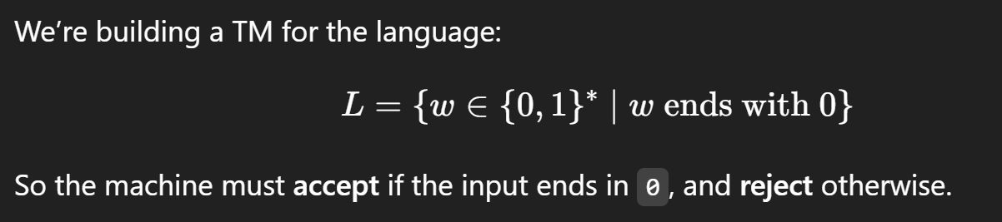

Tape alphabet: {Start, 0, 1, Blank}
States: {q_init, q_0, q_last0, q_last1, q_halt, q_rej}

(q_init, start) (q_start, Start, R)
(q_start, blank) (q_rej, blank, S)

(q_start, 0) (q_last0, 0, R)
(q_start, 1) (q_last1, 1, R)

(q_last0, 0) (q_last0, 0, R)
(q_last0, 1) (q_last1, 1, R)

(q_last0, blank) (q_halt, blank, S)

(q_last1, 0) (q_last0, 0, R)
(q_last1, 1) (q_last1, 1, R)

(q_last1, blank) (q_rej, 1, S)

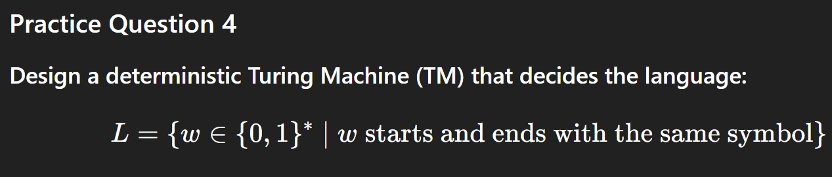
Qfirst_0,0—qlast_0

Tape Alphabet: {start, 0, 1, blank}
States: {q_init, q_first0, q_first1, q_last0, q_last1, q_halt, q_rej}

(q_init, start) (q_start, start, R)
(q_start, 0) (q_first0, 0, R)
(q_start, 1) (q_first1, 1, R)
(q_start, blank) (q_rej, blank, S)

For q_start0
(q_first0, 0) (q_last0, 0, R)
(q_first0, 1) (q_last1, 1, R)

(q_last0, 0) (q_last0, 0, R)
(q_last0, 1) (q_last1, 1, R)

(q_last0, blank) (q_halt, blank, S)
(q_last1, blank) (q_rej, blank, S)

For q_start1
(q_first1, 1) (q_last1, 1, R)
(q_first1, 0) (q_last0, 0, R)

(q_last1, 1) (q_last1, 1, R)
(q_last1, 0) (q_last0, 0, R)

(q_last1, blank) (q_halt, blank, S)
(q_last0, blank) (q_rej, blank, S)



Tape alphabet:{start, 0, 1, blank}
States:{q_start, q_init, q_rej, q_halt, q_seen1, qseen0, q_seen10}
(q_init, start)(q_start, start, R)
(q_start, blank) (q_rej, blank, S)

(q_start, 0)(q_seen0, 0, R)
(q_start, 1) (q_seen1, 1, R)

(q_seen0, 0)(q_seen0, 0, R)
(q_seen0,1)(q_seen1, 1,R)
(q_seen0, blank)(q_rej, blank, S)

(q_seen1, 1)(q_seen1,1,R)
(q_seen1, 0) (q_seen10, 0, R)
(q_seen1, blank) (q_rej, blank, S)

(q_seen10, 0)(q_seen10, 0,R)
(q_seen10, 1)(q_seen10, 1, R
(q_seen10, blank), (q_halt, blank, S)

101010

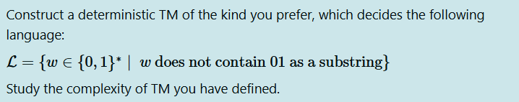

tape alphabet: {start, 0, 1, blank}

states: {q_init, q_scan, q_seen0, q_halt, q_rej}

(q_init, start) --> (q_scan, start, R)

(q_scan, 1) --> (q_scan, 1, R)

(q_scan, 0) --> (q_seen0, 0, R)

(q_scan, blank) --> (q_halt, blank, S)

(q_seen0, 1) --> (q_rej, 1, S)

(q_seen0, 0) --> (q_seen0, 0, R)

(q_seen0, Blank) --> (q_halt, blank, S)

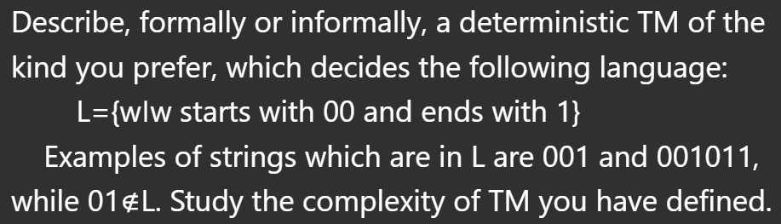

Tape alphabet: {start, 0, 1, blank}
States: {q_init, q_start, q_first0, q_scan0, q_scan1, q_halt, q_rej}

(q_init, start) (q_start, start, R)
(q_start, 0) (q_first0, 0, R)
(q_start, 1) (q_rej, 1, S)
(q_start, blank) (q_rej, blank, S)

(q_first0, 1) (q_rej, 1, S)
(q_first0, 0) (q_scan0, 0, R)
(q_first0, Blank) (q_rej, blank, S)

(q_scan0, 1) (q_scan1, 1, R)
(q_scan0, 0) (q_scan0, 0, R)
(q_scan0, blank) (q_rej, 0, S)

(q_scan1, 0) (q_scan0, 0, R)
(q_scan1, 1) (q_scan1, 1, R)
(q_scan1, blank) (q_halt, 1, S)

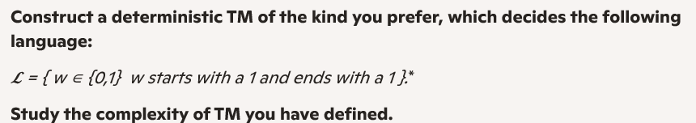

Tape alphabet: {start, 0, 1, blank}
States: {q_init, q_start, q_first1, q_scan0, q_scan1, q_halt, q_rej}

(q_init, start) (q_start, start, R)
(q_start, 0) (q_rej, 0, S)
(q_start, 1) (q_first1, 1, S)
(q_start, blank) (q_rej, blank, S)

(q_first1, 0) (q_scan0, 0, R)
(q_first1, 1) (q_scan1, 1, R)
(q_first1, blank) (q_halt, blank, S)

(q_scan0, 1) (q_scan1, 1, R)
(q_scan0, 0) (q_scan0, 0, R)
(q_scan0, blank) (q_rej, blank, S)

(q_scan1, 0) (q_scan0, 0, R)
(q_scan1, 1) (q_scan1, 1, R)
(q_scan1, blank) (q_halt, blank, S)

Tape alphabet: {start, 0, 1 blank}
States: {q_init, start, q_halt, q_rej, q_even0, q_odd1}

(q_start, blank) → (q_rej, blank, S)
(q_start, 0) (q_odd, 0, R)
(q_start, 1) (q_even, 1, R)

Even:
(q_even,1) (q_even, 1,R)
(q_even,0)(q_odd,0,R)
(q_even, blank) (q_rej, blank, S)

Odd
(q_odd, 1)(q_odd,1,R)
(q_odd, 0) (q_even,0, R)
(q_odd, blank) (q_halt, blank, S)

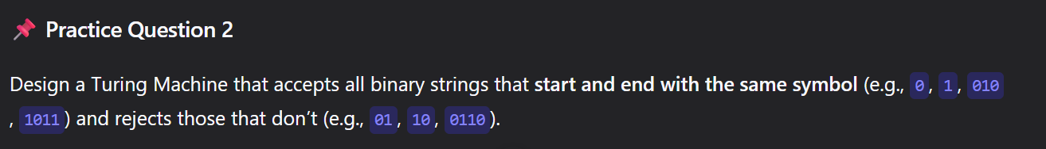
Tape alphabet:{start, 0, 1, blank}
States: {q_init, q_start, q_halt, q_rej, q_st1, q_st0, q_en1, q_en0}
(q_init, start) (q_start, start, R)
(q_start, blank) (q_rej, blank, S)

(q_start, 1) (q_st1, 1, R)
(q_start, 0) (q_st0, 0, R)

(q_st1, blank) (q_halt, blank, S)
(q_st0, blank) (q_halt, blank, S)

(q_st1,1)(q_en1, 1,R)
(q_st1,0)(q_st1,0,R)
(q_en1, blank)(q_halt, blank, S)

(q_st0, 0)(q_en0, 0,R)
(q_st0, 1) (q_en0, 1, R)
(q_en0, blank) (q_halt, blank, S)

